# Project Proposal (Updated)

1. Operating System utility/services:

* file re-organization

1. Programming language(s):

* Python
  + Python Modules:
    - OS - provides a way of using operating system dependent functionality; allows users to interface with the underlying operating system that Python is running on. [Documentation Link](https://docs.python.org/3/library/os.html)
    - Datetime - module supplies classes for manipulating dates and times in both simple and complex ways. [Documentation Link](https://docs.python.org/3/library/datetime.html#module-datetime)
    - Pandas - provides fast, flexible, and expressive data structures designed to make working with “relational” or “labeled” data both easy and intuitive. It aims to be the fundamental high-level building block for doing practical, real world data analysis in Python. [Documentation Link](http://pandas.pydata.org/pandas-docs/stable/)
    - PyQt5 – Qt is set of cross-platform C++ libraries that implement high-level APIs for accessing many aspects of modern desktop and mobile systems. These include location and positioning services, multimedia, NFC and Bluetooth connectivity, a Chromium based web browser, as well as traditional UI development. [Documentation Link](https://pypi.org/project/PyQt5/)
  + Other tools and technologies
    - MySQL
    - MS Access DB
    - MS Excel

1. Prior Programming Knowledge:

Developer, Axander Wilson has been trained in Python while earning a certificate in Data Analytics and Visualization from the University of Central Florida and continues to utilize Python modules while working full-time as a Data Analyst. For projects completed by the developer, please visit the developer’s [GitHub](https://github.com/AxanderW).

1. Project Overview:

The goal of this project to solve a real-world problem for a fleet leasing company. The fleet leasing company currently houses fleet performance analytics data and fleet leasing financial data. The fleet leasing company would like to leverage the data it has collected from its current, past, and prospective customers by consolidating its data stored in separate filing systems and integrating the data into one cohesive file system in order to monetize its valuable data.

1. Business Requirements:

* Monetize fleet data by providing benchmark performance and financial measures customers can use to make smarter asset leasing decisions

1. Technical Requirements:
2. The OS application must locate and then copy all historical fleet utilization data folders/files, fleet fuel economy data folders/files, fleet repair cost data folders/files, and fleet run cost data folders/files all in different directories throughout the company’s data warehouse and then create a new single directory for all these files to live.
3. The company has over 20+ customers. Each of the 20+ customers has its own directory. Additionally, within each customer’s directory, the data folders are further broken down by time period. There are more than 10+ time periods per customer.
4. The OS application must walk from root to branch of each customer, each time period, and each data folder to find files of interest and then copy those files to the new single directory.

Folder Structure Example:

**Level 1: Location of all customer folders**

O:\Services\Private\ANALYTICS\CUSTOMERS

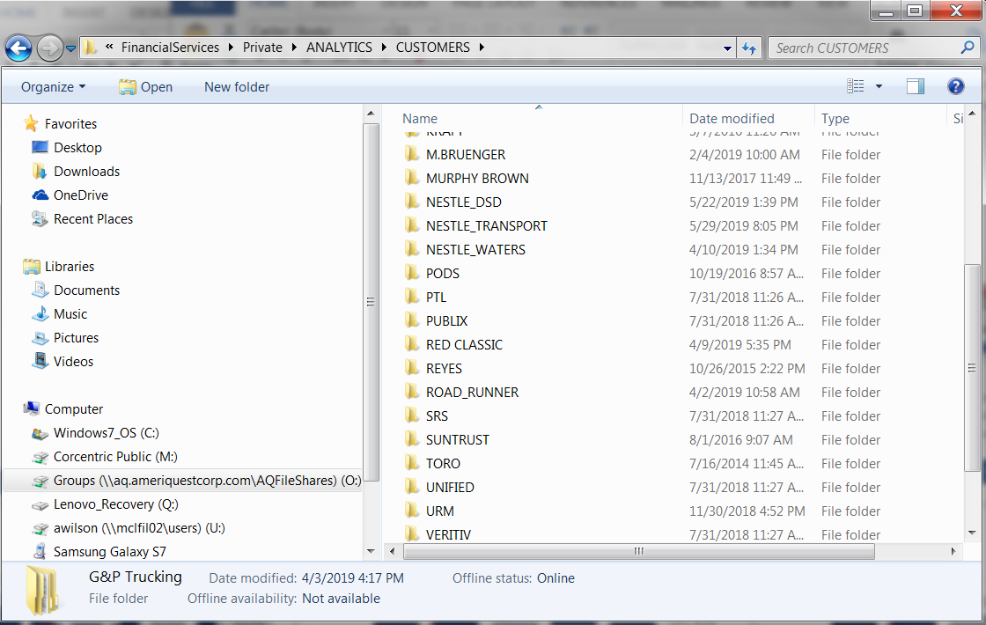

**Level 2: Location of a single customer folder**

O:\FServices\Private\ANALYTICS\CUSTOMERS\NESTLE_TRANSPORT

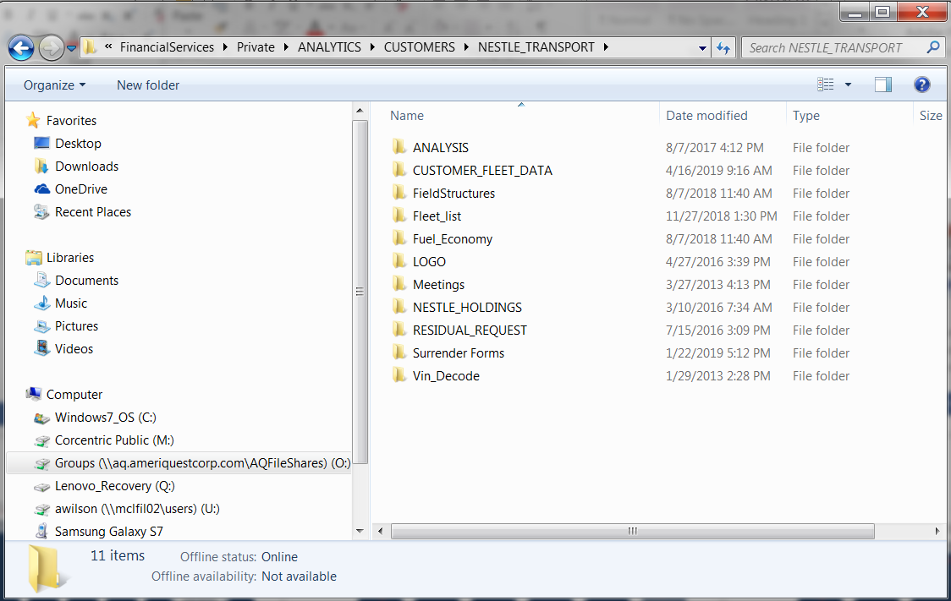

**Level 3: Location of a single time period**

O:\Services\Private\ANALYTICS\CUSTOMERS\NESTLE_TRANSPORT\ANALYSIS

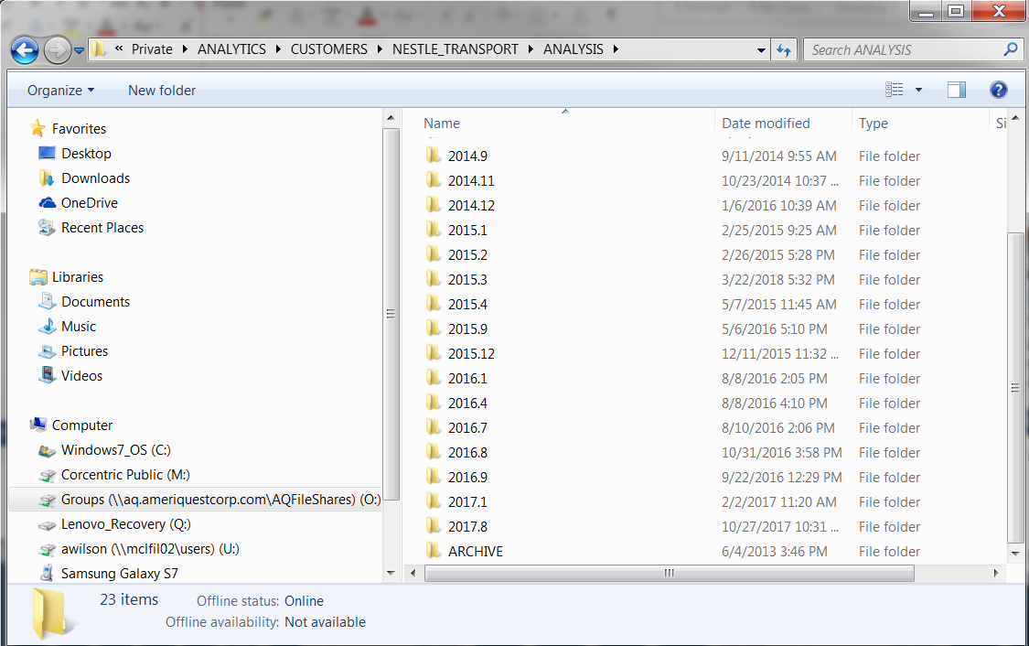

**Level 4: Location of data folders of interest**

O:\Services\Private\ANALYTICS\CUSTOMERS\G&P Trucking\2019.04

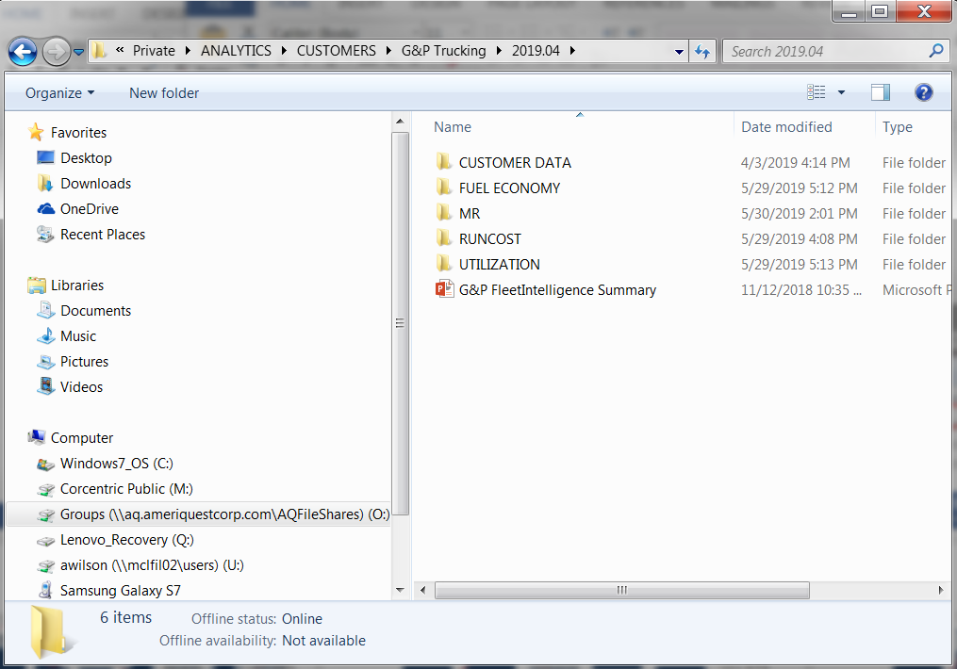

**Level 5a: Fleet Utilization file location**

O:\Services\Private\ANALYTICS\CUSTOMERS\G&P Trucking\2019.04\UTILIZATION

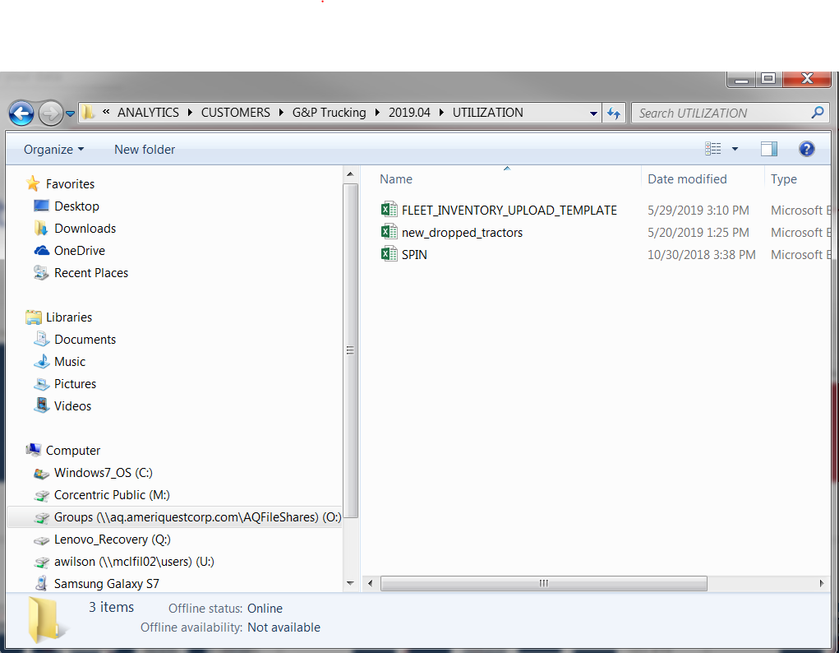

**Level 5b: Fleet Fuel Economy file location**

O:\Services\Private\ANALYTICS\CUSTOMERS\NESTLE_TRANSPORT\ANALYSIS\2017.8\FUEL

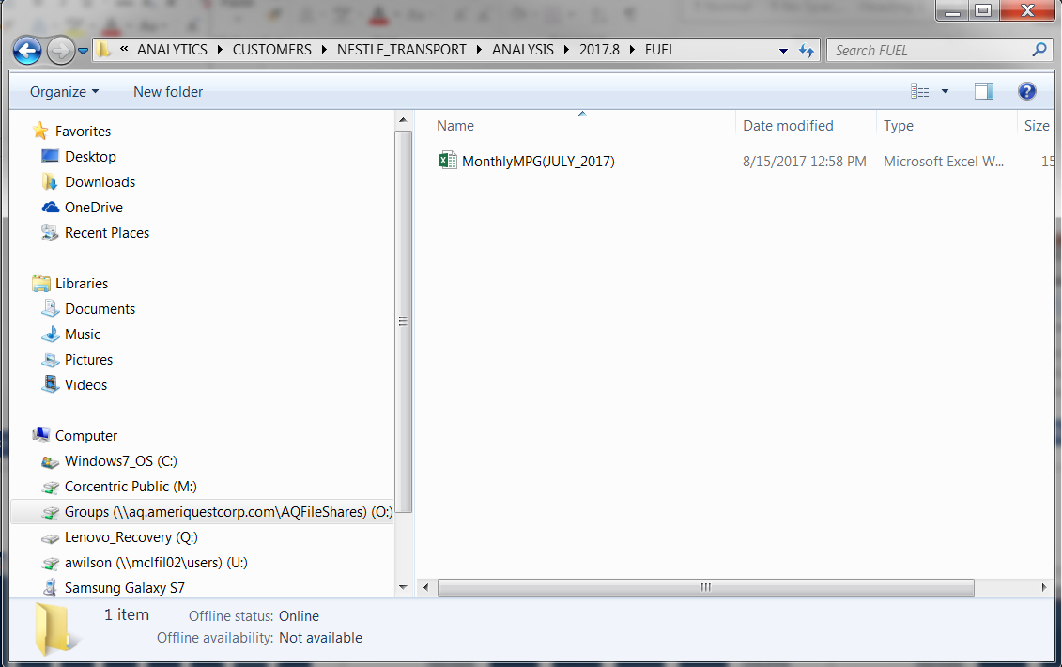

**Level 5c: Fleet Repair Cost files location**

O:\FinancialServices\Private\ANALYTICS\CUSTOMERS\NESTLE_TRANSPORT\ANALYSIS\2017.8\MR

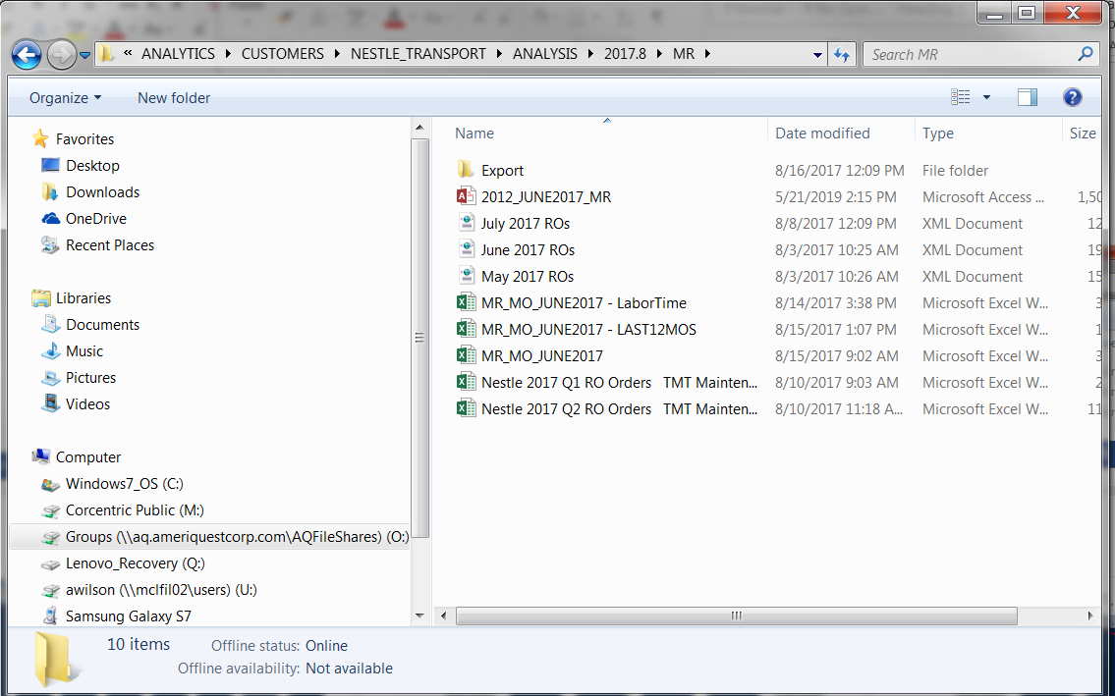

**Level 5d: Fleet Run Cost file location**

O:\Services\Private\ANALYTICS\CUSTOMERS\NESTLE_TRANSPORT\ANALYSIS\2017.8\RUNCOST

